Robert Downing

robertdowning675@hotmail.com

Proposal for earth-sheltered construction

Jan 4, 2023

# Downing Constructions

EXECUTIVE SUMMARY

# Overview

We are excited to share our plan for an Earth-sheltered building. The submitted RFP materials have been examined by our main team, and I do not doubt that our zeal, attention to detail, and prior expertise will enable us to achieve an amazing project conclusion. We are confident that our prior experience managing similar projects will allow us to address these challenges and deliver a successful final product even though this project is accompanied by many challenges, including operating in a densely populated area, adhering to strict schedules, and working within a tight budget.

# Problems

* Unaffordable prices for mid-size projects.
* Lack of communication and transparency

# Solutions Offered

* App-based tracking which provides weekly updates and goals.
* Optimizing the supply chain for our materials to reduce costs thus offering competitive prices.

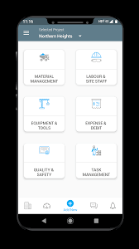

## Introduction:

An earth-sheltered home employs a considerable amount of earth (dirt, soil, subsoil, etc.) as a protective barrier on a significant piece of the house's exterior. These buildings include various energy-saving measures and are frequently intended to use solar energy for heating and cooling. Some designs use recycled materials into their design.

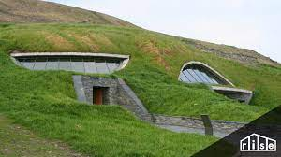

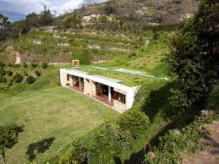

## Advantage of Earth Sheltered Homes:

Earth-sheltered structures have several advantages. Since an earth-sheltered home is less vulnerable to the impacts of severe external air temperatures, you will not experience the effects of bad weather as much as you would in a traditional house. Internal temperatures are more consistent than in traditional dwellings, and interior spaces appear more pleasant with less temperature change.

Earth-sheltered houses require less outside upkeep, such as painting and cleaning gutters, because the earth covers part or all of their exterior. Building a home buried in the dirt or surrounded by earth provides natural soundproofing. Most earth-sheltered house plans "blend" the structure into the environment more harmoniously than a conventional residence. Finally, earth-sheltered homes may be less expensive to insure since their construction provides additional protection from strong winds, hailstorms, and natural catastrophes like tornadoes and hurricanes.

## Disadvantage of Earth Sheltered Homes:

Earth-sheltered houses require less outside upkeep, such as painting and cleaning gutters, because the earth covers part or all of their exterior. Building a home buried in the dirt or surrounded by earth provides natural soundproofing. Most earth-sheltered house plans "blend" the structure into the environment more harmoniously than a conventional residence. Finally, earth-sheltered homes may be less expensive to insure since their construction provides additional protection from strong winds, hailstorms, and natural catastrophes like tornadoes and hurricanes.

## 2.1 Designs:

The various types of earth-sheltered homes are:

### Earth-Covered Homes:

Earthen dwellings only have roofs covered in earth. These roofs are commonly referred to as "living roofs," "green roofs," or "earth roofs." Living roofs might be as simple as earth or soil, or as complex as luxuriant flora and plants. A living roof is common in most other forms of earth-protected dwellings.

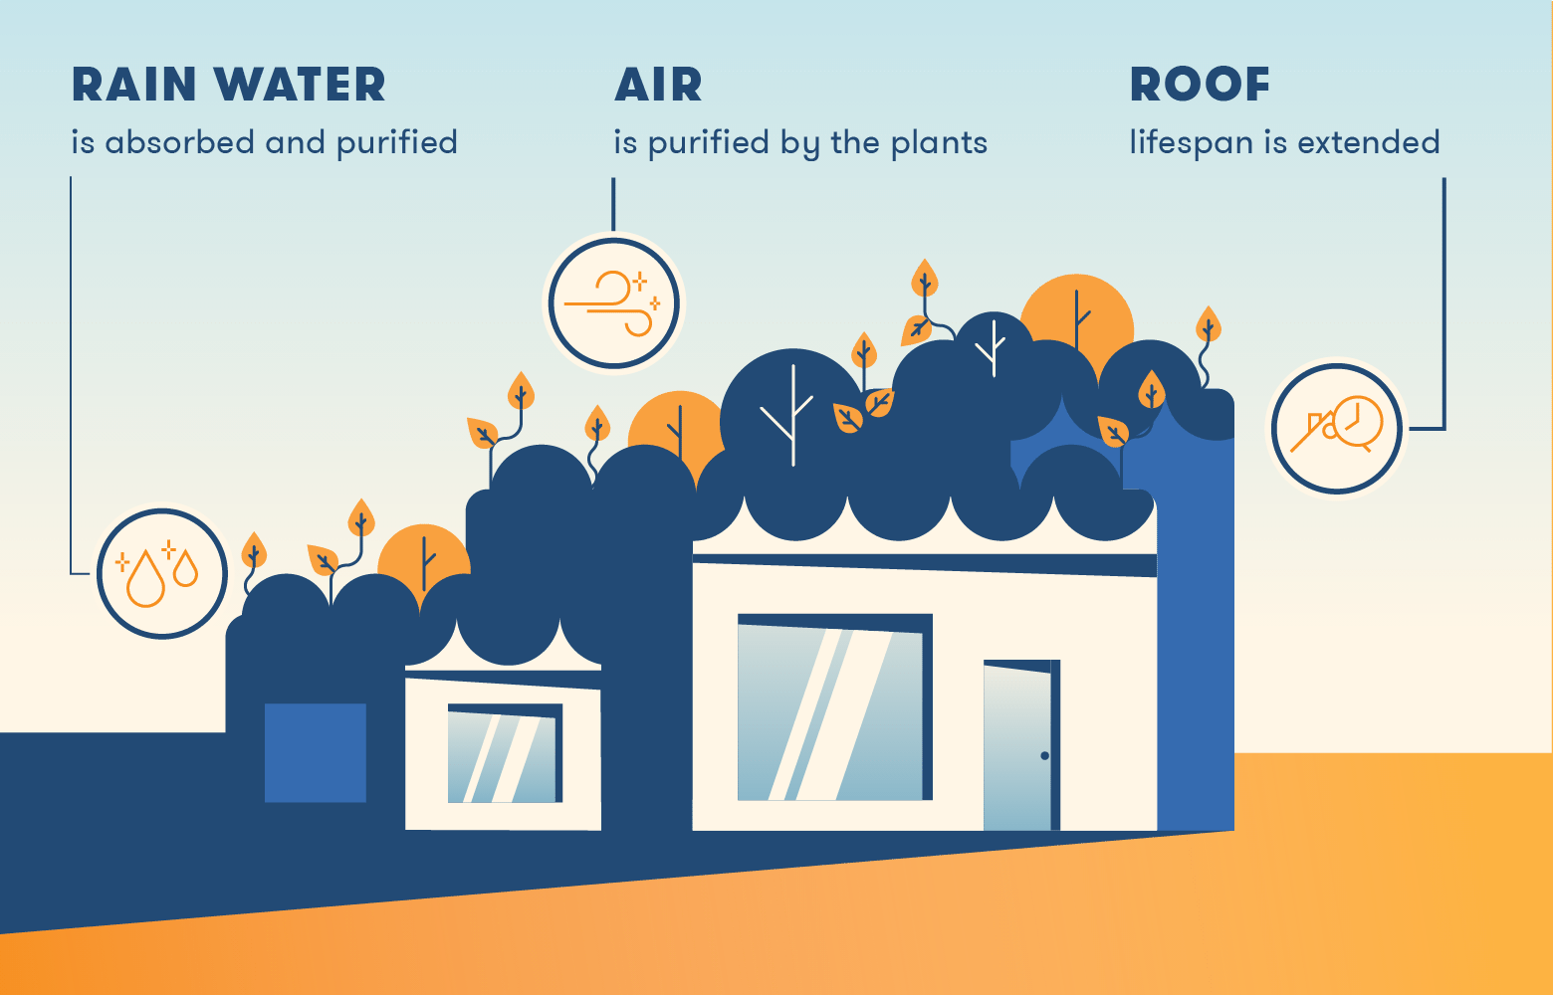

### Bermed Homes:

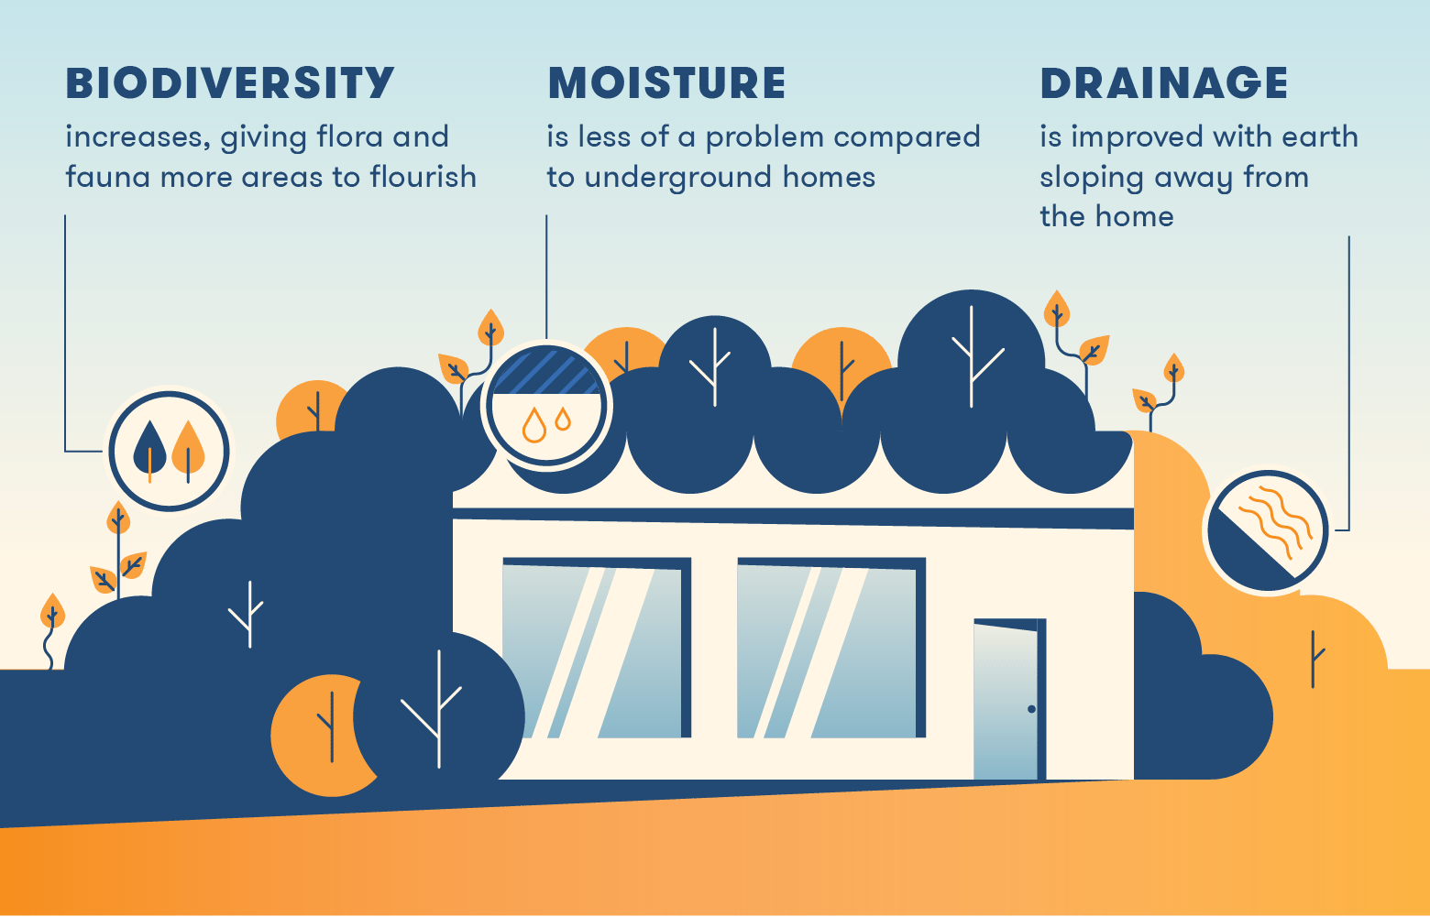Bermed homes typically have earth pushed up against the exterior walls and may have earth covering the roof. The earth surrounding the home helps insulate the interior temperature by absorbing and storing heat. The soil also helps manage storm drainage since the earth against the walls slopes away from the home.

### Underground Homes:

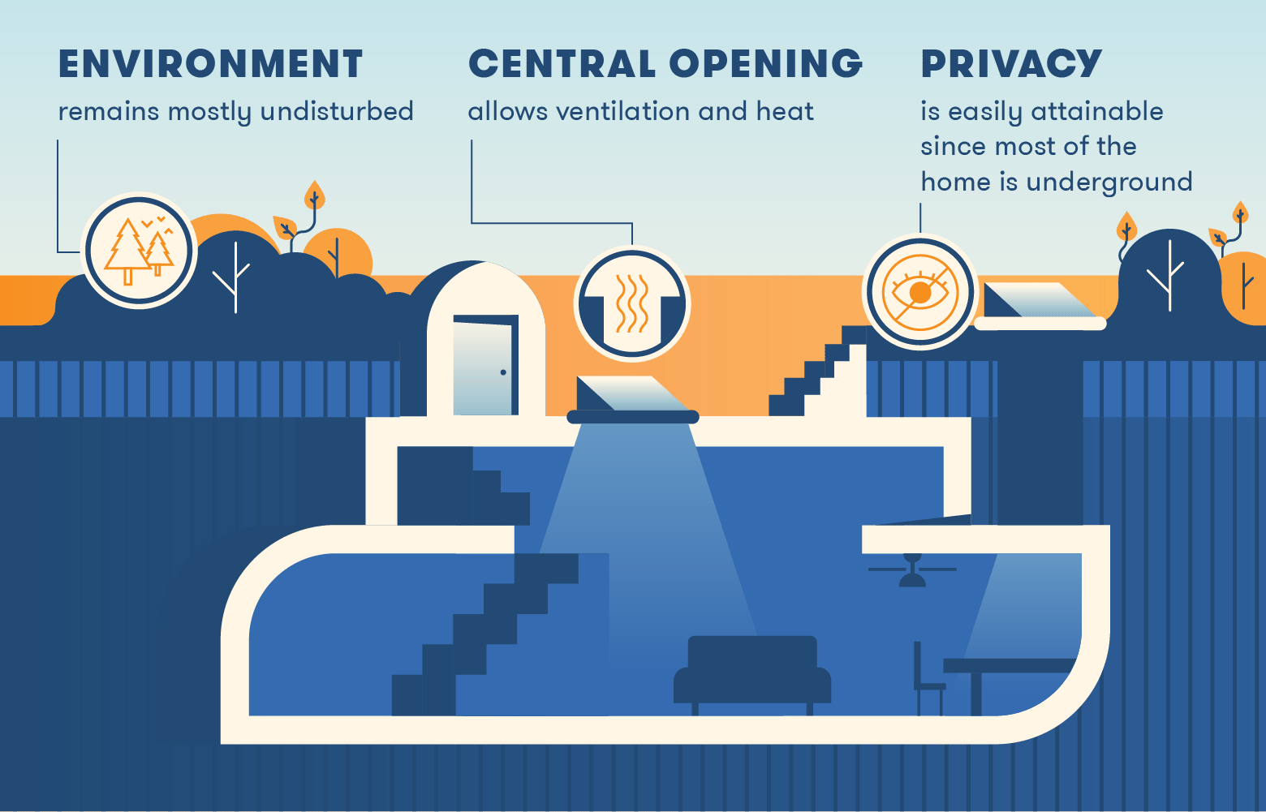Underground earth-sheltered homes are built below ground level and typically feature a central, open atrium or courtyard to allow residents access to light and air. These homes have rooms that need heat like bedrooms and living rooms close to the centre to get the most heat.

## 2.2 Cost:

**Basic Costs**:

$45 per square foot 24′ module (for construction of shell structure only) includes:

* footings
* shell structure (does not include floor, which is poured after plumbing,
* electrical, phone, ductwork, & outlets, and completed at owner’s expense.)
* block-outs & arches in shell & footings
* labour for placement of vents, flues
* labour for installation of electrical conduit
* thermal break insulation as needed
* 28 ft. modules estimated at $50.00 sq/ft

**Drafting costs:**

* $300.00 per 24 square foot module
* $350.00 per 28 square foot module
* to be paid at time of Site Analysis

**Waterproofing:**

* Standard non-VOC waterproofing, applied at $2.25/square foot of  
  surface area
  + Freight charges to be determined per job
* Premium waterproofing is available, apply at $4.25/square foot of   
  surface area, which includes:
  + 10 mil membrane
  + Drainage mat & Protection Board
  + 10-year manufacturer’s written warranty
* Travel costs are charged in addition to waterproofing charges.

**Skylights:**

* 6′ octagon – $3,000.00
* 3′ x 3′ square – $2,200.00

**Loop System(duct work):**

* Installation of 6″, sch40
* Installation of 8″, sch40

**Special Design Work:**

* Our consulting time is based on $120 per hour.
* Engineering is required, charges will be per engineer’s billing.
* Special design costs will be billed as incurred and due upon billing.

**Travel Expense:**

For construction that is 40 miles outside of the Construction area, the Owner   
will pay for:

* Motel accommodations for work crew (4-5 people)
* $30.00 per man per day meal allowance
* Moving and transport expenses will be determined per job.
* For out-of-state expenses, there will be additional costs determined accordingly

**Design & Preliminary Construction Contract:**

A preliminary drawing will be provided to the Client for his review and changes and will be returned to Downey Constructions for Final Plans to be drawn. Any changes to Final Plans will be made and billed at the rate of $120.00 per hour. All VA/FHA specification requirements will be billed at cost.

**Consultation Cost:**

Initial consultation for the preparation of the “working drawing” will be at no charge. Upon signing of the contract, six (6) hours of technical consultation relative to the construction of the home will be provided at “no charge”; thereafter, consultation will be billed at $120.00 per hour.